Cloud native applications are composed of reusable components known as microservices and are designed to integrate into any cloud environment. This flexible and scalable approach is ideal for enterprises who are tasks with improving existing applications, building new applications, and enhancing user experience.

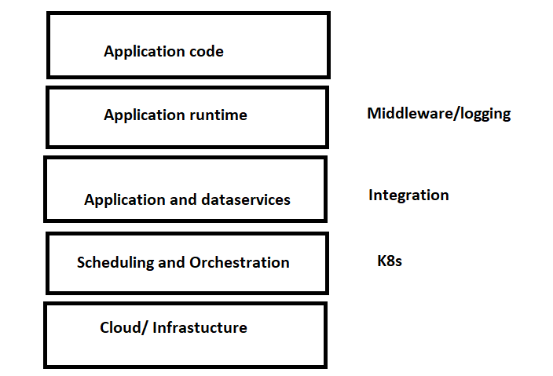

Monolithic application:

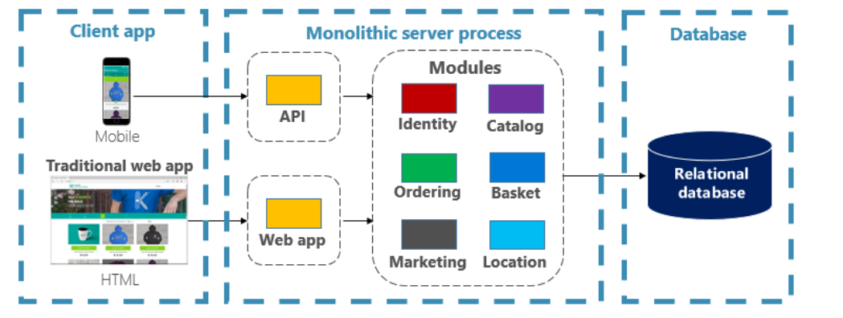

CNF application:

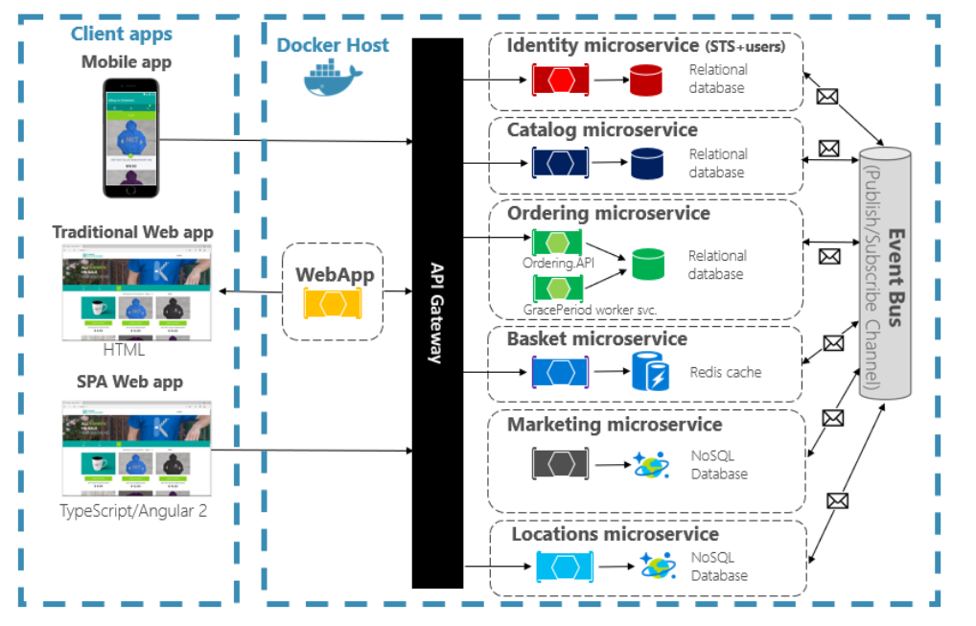

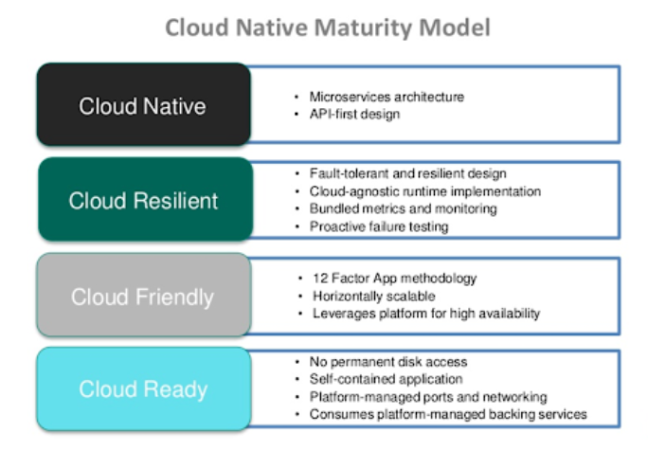

An application can be called cloud native if:

1. It has autoscaling feature
2. If it can run on any cloud